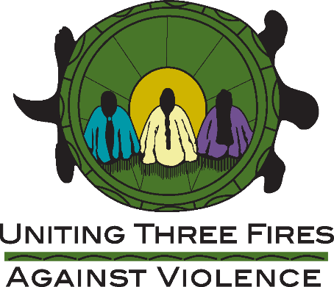

SHAWL MAKING VIDEO
REQUEST FOR PROPOSAL

Uniting Three Fires Against Violence (UTFAV), Michigan’s Tribal Domestic Violence and Sexual Assault Coalition, is seeking culturally honoring consultant services intended to provide a video teaching on shawls. This can include steps and instructions on how to make a shawl, in addition to any relevant teachings about shawl making and wearing within our Tribal communities. UTFAV seeks those candidates who have significant experience and expertise in working with American Indian/Alaska Natives.

The primary goal of the video is to provide interested individuals with a lesson on how to add fringe to a shawl, in addition to relevant teachings and information about shawls in tribal communities. It is expected that Consultants will be available for a recorded session, with materials provided by UTFAV.

TIMELINE
It is expected that the video will be recorded before 5/31/22.

EMAIL NOTIFICATIONS
All correspondence including confirmations and reminder notifications will be sent to the email included within the submission only. Notification emails will come from hmckelvie@utfav.org

PROPOSALS WILL BE RATED ON:
Qualifications and experience level of consultant (50%)
Value of proposed output (25%)
Proposed budget and timeline (25%)

Proposal submission deadline: May 20, 2022
Selection notifications will be made by May 23, 2022.

Uniting Three Fires Against Violence
Proposal Deadline: May 20, 2020

CONSULTANT INFORMATION
Name:
Job Title:
Organization:
Address:
City/State/Zip:
Phone:
Email:
Tribal Affiliation:
*Please attach a short bio (<200 words)

Hourly Rate:

Expected Timeline:

Please discuss your experience working with with American Indian and Alaska Native communities and individuals:

Please discuss how your experience will support the intended goal of project: (including any experience in working with previous shawl making projects):

