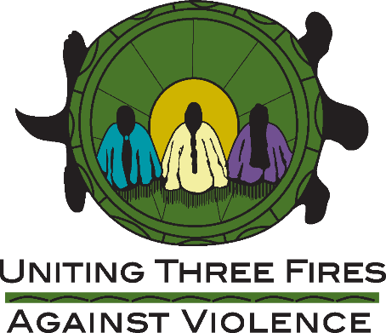

MISSING AND MURDERED INDIGENOUS PEOPLE TOOLKIT PROJECT
REQUEST FOR PROPOSAL

Uniting Three Fires Against Violence (UTFAV), Michigan’s Tribal Domestic Violence and Sexual Assault Coalition, is seeking consultant services intended to provide input and recommendations in conjunction with a group of subject matter experts from the following arenas; law enforcement, criminal justice, advocacy, social services, and other subject matter experts in order to guide the development of the Missing and Murdered Indigenous People (MMIP) Toolkit. UTFAV seeks those who can address the complex and unique issues related to domestic violence, sexual violence, stalking, teen dating violence, sex trafficking, and how those issues may coincide with MMIP. Consultants must also have significant experience and expertise in working with American Indian/Alaska Natives.

The primary goal of the Toolkit is to provide a resource toolkit intended for families, individuals and Tribal communities and governments that experience their tribal relatives either going missing and/or being murdered. UTFAV seeks consultants that have significant experience working in conjunction with tribal, federal and state law enforcement and criminal justice officials, advocates, and others working to enhance the safety of American Indians and Alaska Natives. It is expected that Consultants will be available for in person meetings, in addition to the review and editing of documents created in the development of the MMIP toolkit.

TIMELINE
The development of the MMIP Toolkit is expected to be a two-phase project. Phase One will begin in September 2020 and should be completed tentatively by December 2020. Phase Two will begin in January 2021 and will be completed tentatively by July 2021. It is expected that there will be one in person meeting in Phase One (approximately two day meeting) and two in person meetings in Phase Two (The two meetings will be broken down into an initial two day meeting and a one day meeting/training to launch the draft toolkit).

TRAVEL
UTFAV will cover travel for consultants based off GSA rates. All travel expenses will be reimbursed, including lodging, airfare, ground transportation, baggage, and per diem.

EMAIL NOTIFICATIONS
All correspondence including confirmations and reminder notifications will be sent to the email included within the submission only. Notification emails will come from vpatzwald@utfav.org

PROPOSALS WILL BE RATED ON:
Qualifications and experience level of consultant (50%)
Value of proposed output (25%)
Proposed budget and timeline (25%)

Proposal submission deadline: September 18, 2020.
Selection notifications will be made by September 25, 2020.

Uniting Three Fires Against Violence
Proposal Deadline: September 18, 2020

CONSULTANT INFORMATION
Name:
Job Title:
Organization:
Address:
City/State/Zip:
Phone:
Email:
Tribal Affiliation:
*Please attach a short bio (<200 words)

Hourly Rate:

Expected Timeline (include time for meetings):

Please discuss your experience working with either Tribal, State and/or Federal Law Entities to enhance the safety of American Indian and Alaska Native communities and individuals:

Please discuss how your experience will support the intended goal of the MMIP Toolkit Project (including any experience in working with prior MMIP projects):

